RUGBY CANADA – CANADIAN RUGBY FOUNDATION



GRANT MANUAL
Revised February 2026

Process for Rugby Canada Disbursements to Grant Applicants as Referenced in the Rugby Canada – Canadian Rugby Foundation Memorandum of Agreement dated April 22, 2022.

TABLE OF CONTENTS

- Introduction | 3
- Funding Overview | 3
- Requests by Grant Applicants  - Donation Request by Rugby Canada to CRF  - Donation to Rugby Canada by CRF  - Grant Results and Use of Funds Report by Grant Applicants  - For More Information  - Grant Process  Links to Grant Process Forms | 4  7  8  9  10  11  13

1. INTRODUCTION

Rugby Canada is committed to building stronger communities through sport and supports the growth and development of amateur rugby in all parts of Canada. This Rugby Canada Grants Manual describes how Rugby Canada disburses money to Fund Partners of the Canadian Rugby Foundation and contains details on the processes, procedures, criteria, rules, and guidelines for grant applications, budgets, and reporting of project results and spending.

A Grant Applicant is a rugby club, Provincial Rugby Union, or student awards sponsor with an active CRF fund seeking a grant from Rugby Canada to meet its funding needs. Each should be familiar with the contents of this Manual and ensure their project is always compliant with Rugby Canada and Foundation requirements.

The Manual describes the collaborative partnership between Rugby Canada, the Canadian Rugby Foundation, and its Grant Applicants. This manual has been created to ensure the needs of all three parties are met to ensure valuable projects for and on behalf of the Canadian amateur rugby community continue to be funded when needed.

2. FUNDING OVERVIEW

Rugby Canada is supportive of raising funds to benefit amateur rugby in Canada by partnering with Provincial Rugby Unions and their Member rugby clubs on projects that promote participation, competition, or governance of rugby – all to grow and develop the sport of rugby union in Canada.

Rugby Canada is a Registered Canadian Amateur Athletic Association (RCAAA) charged with promoting and developing amateur rugby across Canada. Through its network of rugby clubs in every province and the territories, Rugby Canada encourages rugby clubs with Funds in the Canadian Rugby Foundation to apply for grants to finance rugby-related projects which may include rugby club operating expenses and capital expenditures. Once a project (including its budget, schedule, and donation solicitation plan and materials) has been reviewed and approved by Rugby Canada, Rugby Canada makes a request of the Canadian Rugby Foundation to donate sufficient funds to support the project’s budgeted financial needs. Upon approval by the Foundation, the Foundation provides a payment to Rugby Canada as one of its “qualified donees” and upon receipt, Rugby Canada provides a cheque or other payment to the project sponsor/grant requestor.

Working together with the Fund sponsors of the Canadian Rugby Foundation, Rugby Canada encourages those Fund sponsors to apply for and receive grant funding from the donations made to Rugby Canada by the Canadian Rugby Foundation.
3. REQUESTS BY GRANT APPLICANTS

ORGANIZATION ELIGIBILITY REQUIREMENTS

For your project to be eligible for approval your organization must be a Fund sponsor of the Canadian Rugby Foundation.

Organizations must maintain these eligibility requirements throughout the life of the project, not just
at the time the project application is submitted.

PROJECT ELIGIBILITY REQUIREMENTS

The charitable objectives of Rugby Canada are to raise funds to grow, develop and promote amateur rugby by identifying projects operated by eligible organizations that align with the National Growth Plan 2025-2030 which includes five core pillars of action:

1. Evolve the athlete development pathway to support all ages and stages
2. Introduce and grow non-contact rugby to increase access and retention
3. Focus on youth development to build a stronger base for the sport
4. Invest in women and girls to accelerate equity and opportunity
5. Build capacity within clubs and provincial unions to sustain progress

TYPES OF PROJECTS CONSIDERED

Any donations made by the Foundation to Rugby Canada must be used towards activities and projects aligned with the Foundation’s object to develop and grow rugby across Canada. Responsibility for ensuring the funds are used for the purposes intended is jointly held by the Foundation’s Board of Directors and Rugby Canada, and must be compliant with CRA requirements.

As a guiding principle, no grant from Rugby Canada to a Grant Applicant may benefit individuals who have donated to that Fund and received a tax receipt.

Rugby Canada typically categorizes projects according to how the funds will be used. The list below is
meant to provide a grant requestor with an idea of what kinds of projects can be approved - your project
may have elements of one or more types of projects. Frequently, the “project” is a rugby club’s annual operating budget or some portion of it.

- OPERATING EXPENSES including any of the following:
- Facilities and rugby programs
- Labour expense - Salaries and benefits or Honoria for staff
- Professional fees
- Member services
- Administration
- Provincial or national rugby union fees
- Competitions
- Miscellaneous

- CAPITAL EXPENDITURES including any of the following:

- Equipment (facilities, strength & conditioning, training)
- Land and clubhouse purchase, development or long-term lease all in accordance with Canadian Rugby Foundation and Rugby Canada CRA approved guidelines. Capital expenditures of this type are generally handled through Foundation Capital Funds, not an Endowment Fund which is meant to be invested in perpetuity.

- AWARDS including any of the following:

- Donations to universities for student Athletic Financial Awards (AFAs)
- Awards, bursaries awarded to students entering or enrolled in a university or college, said student previously contributing to rugby as a player, coach, volunteer, staff, or official.
- Needs-based support (bursaries) awarded to students entering or enrolled in a university or college seeking to advance their development in rugby
- Performance-based award to recognize outstanding performance and potential as a rugby player or coach.

SUBMITTING YOUR GRANT APPLICATION

Grant requests must be made by completing and submitting a “Grant and Donation Request” – Form 1. The request must describe how the funds will be used in accordance with the project’s stated objectives - a brief narrative will suffice. If possible, also attached an itemized list:

- Contact information: list the member of your organization who will be responsible for the administration of your project. You can add other individuals for our contact list once your project has been approved. Please be sure to include your non-profit registration number.
- Project name: be as brief and descriptive as possible as the name of your project will appear in your communications materials and at the top of its website funding page.
- Start date: your anticipated start date. It can be a target date or as soon as approved.
- Completion date: if your project has a finite completion date then enter that date. If your project will be sustained indefinitely then enter “ongoing”. Note that capital projects must have a completion date, they cannot last indefinitely.
- Project description: briefly explain the organizational issue(s) to be addressed and the project’s goals and objectives and how the project will achieve them. If you need more space then provide your project description as an appendix to your application. Note that the project description you provide will be used for your project’s donation web page and will be seen by potential supporters of the project. It should be a strong communication piece selling the goal of and benefits from the project.
- Project budget: if your project has a fixed completion date (for example, a capital project) then enter your total project budget. If your project is ongoing then enter your anticipated annual budget. For many projects the budget will depend on the amounts raised. If this is the case use your best estimate and explain your rationale in the next section. Your budget must show how all revenues (Rugby Canada grants and other sources of revenue) will be used to offset the expenses that correspond with the project objectives.
- Grants received from Rugby Canada will be used to pay for: provide a brief narrative of the items in your budget and explain your rationale for any significant estimates. If you need more space then you can add an appendix or include the information in the project budget you provide (refer to project budget).
- Describe how this project will assist in promoting or developing sport in Canada.

IMPORTANT:

- You MUST include a project budget with your application and provide your banking information.
- You MUST include a Grant Results Form 3 summarizing how the previous year’s grant was used if applicable.
- All project applications MUST be signed by the required authorized individuals. An authorized representative is an officer or director of an organization or other individual appointed by the board of directors to act on the organization’s behalf.
- Email your completed project application to Rugby Canada at: crfgrants@rugby.ca , and cc Jeff Chan, the Foundation’s Chief Executive Officer.
GRANT APPROVAL PROCESS AND TIMELINES

Grant requests that have a total or annual budget of $25,000 or less will be reviewed by Rugby Canada and will be approved within 5 business days.

Projects that have a total or annual budget of more than $75,000 may require additional levels of approval to assess their suitability and sustainability, as well as financial and operational viability. These requests will be approved within 10 business days.

Email your completed and signed Grant Request Form to crfgrants@rugby.ca to begin the process. Grants are paid by EFT. Please be sure to provide a copy of a cheque drawn on your organization or a direct deposit form from your bank.

NOTE: we endeavor to process your grant request as soon as possible, but please allow up to three
weeks from the time you submit your request to receive funds, depending on the size of the grant.

4. DONATION REQUEST BY RUGBY CANADA

Once the Grant Request from a Grant Applicant has been received, reviewed and approved by Rugby Canada, it is forwarded to the Canadian Rugby Foundation as a Donation Request (Part II of Form 1). The requesting Grant Applicant will be copied on this submission to acknowledge this step has been completed.

The CRF reviews the donation request, and if the Grant Applicant is eligible in all respects, and the Grant Request is in order and within the allowable amount, approves the Donation Request, processes a payment, and forwards it to Rugby Canada with its CRF Donation Declaration – Form 2.

Charitable Tax Receipts for Qualifying Donations

Only a Qualified Donee (a registered charity, a branch of municipal, provincial or federal government, a Canadian university, or Registered Canadian Amateur Athletic Association or RCAAA) can issue tax receipts for qualifying donations made to enable the donee to fulfill its charitable purpose. Rugby Canada is a RCAAA and the Canadian Rugby Foundation is a registered charitable public foundation, so donations to either organization may qualify for a tax receipt.

A qualifying donation is where there is intent to make a gift that is a complete transfer of property that is voluntary and unconditional. Specifically:

- The donor has an intent to make a gift and intends to “become poorer” as a result of the transaction and there is no material benefit to the donor or a related party;
- The gift is one of property (a cash, cheque or credit card payment, marketable securities, or other valuable tangible assets), not a donation in kind or provision of time or services;
- The transfer of property is complete, the donor surrenders all control of the property; a pledge is not a gift;
- The gift is voluntary, there can be no compulsion to act; and
- The gift is unconditional - the donor cannot compel the donee to use the gift for a specific purpose.

When the Canadian Rugby Foundation makes a gift to Rugby Canada to benefit a Grant Applicant’s project or activity, it agrees to the following statement which is embedded in the CRF Donation Declaration – Form 2:

“We represent and warrant that we are voluntarily and unconditionally giving this gift to Rugby Canada to benefit the development of amateur rugby in Canada. We understand that Rugby Canada can direct my donation how it wishes, however my preference is that my gift be used to support the project selected above.

Consistent with Canada Revenue Agency’s interpretations of “qualifying donations”, we confirm that no material benefit will accrue to me or related parties as a result of this donation, and that this gift does not or will not reduce any obligation, directly or indirectly, that we or related parties have for “non-qualifying” expenses such as membership dues, training, or program registration fees, travel costs or other like expenses that we or related parties would normally be required to pay. We also understand that civil penalties can be imposed against us for the misrepresentations of tax matters. Based on these facts, we understand that an official receipt for tax purposes will be issued in respect of this gift.”

5. DONATION TO RUGBY CANADA BY THE FOUNDATION

Upon receipt of the donation funds and Donation Declaration Form from the Foundation, Rugby Canada will allocate the money to a specific project, and process an EFT to the Grant Applicant to the bank account referenced in the Grant Request.

Consistent with CRA requirements, Rugby Canada cannot guarantee that a Foundation donation will be used for a specific purpose, but it is important to note that it is Rugby Canada’s policy to honor its donors’ wishes and to allocate gifts to projects accordingly.

6. GRANT RESULTS AND USE OF FUNDS REPORT

Following the completion of the project for which the grant was made or after 12 months, whichever comes first, the Grant Applicant must complete and submit the Grant Results and Use of Funds Report – Form 3 to Rugby Canada to be kept on file.

Grant Results and Spending Reporting
All grant spending must be incurred in the pursuit of your project’s objective(s) and for no other purposes under any circumstances. Grants spent on anything other than your project’s objectives can be viewed as fraud and may result, at a minimum, in the project being delisted and the organization being suspended from future participation.

All project expenses must be paid by cheque or other means where the recipient of the payment can
be verified. Avoid paying for project expenses in cash.

A completed Grant Results and Use of Funds Report (Form 3) must be submitted to Rugby Canada at crfgrants@rugby.ca within 30 days after the project completion date indicated in the Grant Request. You do not need to include copies of receipts and invoices with your project report, but you do need to keep these items on hand in case they are requested at a later date. The project report narrative must:

- Include a financial summary describing the sources and uses of all funds related to the project including the Rugby Canada grant. The summary does not need to be detailed but should provide a reasonable level of information of how the funds were used. For example, if $2,000 was used to help pay for 3 coaches, it’s fine to say “$2,000 was used for coaching costs”, you don’t need to provide additional detail like “$2,000 was used to help pay for coaching - $300 for coach X, 600 for coach Y, and $1,100 for coach Z”.
- Describe how the expenses that were funded by the grant enabled your project to reach its objective(s).
- If your project and the grant covers direct athlete expenses like competition entry costs, travel, and accommodation, you MUST attach a list of participants who benefited.
- Rugby Canada must have received a completed Grant Results and Use of Funds Report before the issuance of any further grants. In the event that a grant recipient fails to submit a project report within three months of the completion date (or 12 months), the project may be deregistered and any donations allocated to the project may be reallocated to other approved projects. Further, the Grant Applicant may be ineligible to apply for new projects until the project report is received.
- Projects that receive grants of more than $75,000 must submit documentation to support ALL expenses related to the grant funding.
- Project reporting is a critical component of Rugby Canada’s grant program. Your project reports help Rugby Canada ensure that its grants are being used in a manner consistent with its charitable purpose and that Rugby Canada is compliant with Canada Revenue Agency’s requirements for registered charities.
Thank you in advance for your help and support!
7. FOR MORE INFORMATION

For the most recent version of this manual and all project forms, please click here.

To contact Rugby Canada regarding grants, please email Jamie Levchuk (Managing Director, Operations & Game Development) at: jlevchuk@rugby.ca.

To contact the Canadian Rugby Foundation regarding grants and donations, please email Jeff Chan, Chief Executive Officer, at jeffachan@gmail.com

8. GRANT PROCESS

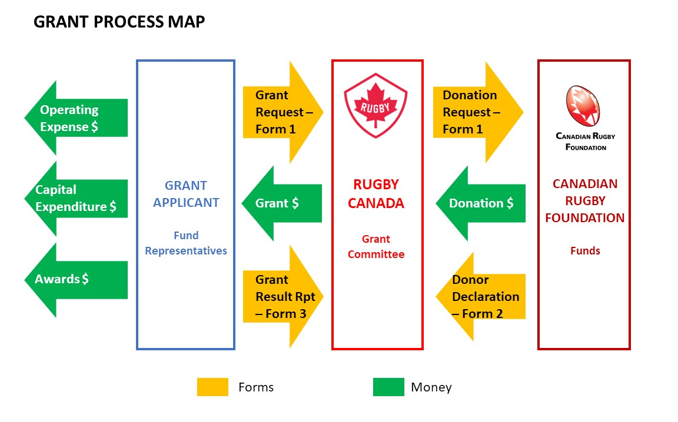
GRANT PROCESS STEPS

Grant Process Steps | Grant Applicant | Rugby Canada | Canadian Rugby Foundation
- Grant Applicant (GA) advises Foundation (CRF) it will be requesting a grant. | X
- CRF sends out Grant Request – Form 1 Part I to the GA. |  |  | X
- GA completes and submits Grant Request (Form 1 – Part I) to Rugby Canada (RC) with a copy to CRF | X
- RC reviews Grant Request, works with GA to revise if necessary, and approves or denies the request. |  | X
- RC forwards the signed Grant Request to the CRF to request a donation in the amount of the approved grant (Form 1 – Part II). |  | X
- CRF reviews Donation Request, ensures eligibility of GA, sufficient money available in the fund for release, and compliance with objectives. |  |  | X
- CRF processes EFT payment to RC, completes the CRF Donation Declaration (Form 2), with preferred allocation, and forwards to RC. |  |  | X
- RC receives payment from CRF, allocates the money to the (preferred) project and processes grant payment, and forwards to the GA. |  | X
- GA spends the grant on the expenses or projects indicated on the Grant Request (and on no other items) and completes the project. | X
- GA completes the Grant Results and Use of Funds Report (Form 3) and submits to RC with copy to CRF. | X
- RC reviews the Grant Results and Use of Funds Report, contacts GA if clarification is required, and records grant as complete and the GA as eligible for future grants. |  | X

LINKS TO GRANT PROCESS FORMS:

- FORM 1: Grant Request

- FORM 2: CRF Donation Declaration

- FORM 3: Grant Results and Use of Funds Report

